INFORMATION FOR THOSE WHO LIVE OR WORK IN BASTVÅLEN, MILLMARK, SÖRMARK, VADJE, OR ÖSTMARK, FOR TORSBY RESIDENTS AND ALL OTHER VÄRMLANDERS
(This information comes from the Collaborative Group for Nature and Cultural Protection in the area. We consist of residents, part-time residents, and landowners who have organised to gather local knowledge and stand up for the future of this place. We are closely following Fortum’s plans for a large-scale pumped storage hydropower plant at Bastvålen.)
The exploitation that Fortum is planning for what is currently a natural area – including parts of Hovfjället’s recreational area, Finnskogen, and cultural landscapes as well as habitats for people and animals – is not an isolated geographical problem in Bastvålen; it will affect us all.
Fortum’s project is currently in the consultation phase and could have major and lasting consequences for the entire region.
THIS COULD AFFECT YOU
• Water levels, fishing opportunities, and access to drinking water will change.
• Roads will be closed or affected – including Häckfall–Vadje, Bastvålen–Östmark, and several forest roads.
• Forests and hunting grounds will disappear, and public access rights will be restricted.
• Noise, light pollution, and vibrations in previously quiet landscapes.
• Multi-generational homes, holiday houses, and living environments are under threat.
• The landscape will be permanently changed – affecting outdoor life and tourism.
• Property values and security will be negatively affected.
• Hovfjället’s nature reserve will be impacted – despite its status as a national outdoor recreation interest area.
• The cultural heritage of Finnskogen is at risk of being pushed aside – with old farms, stories, and traces of the Forest Finn settlements that are part of our shared heritage.
• We will become a risk zone in times of war.
• We risk losing our local shop and service point, ICA Boa, if the customer base declines during the construction period and when people choose to leave the area.
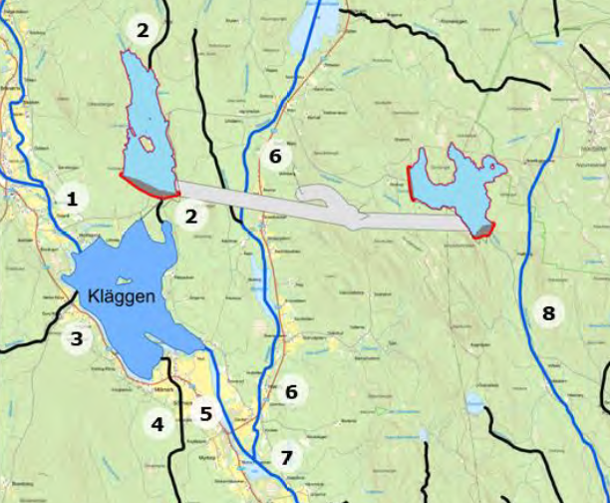

In Fortum’s documentation for the environmental code’s delimitation area, ahead of its permit application for the new pumped storage hydropower plant, the plans are described, which we interpret and try to illustrate as follows:
- Two new dams – totalling approximately 400 hectares of lost natural land.
The two dams together with the approximately 8 km long tunnel that will be built are estimated to take up around 400 hectares of natural land.
That is equivalent to a four-lane motorway stretching 160 km – from Bastvålen north of Torsby to Åmål.
The dams are planned to have walls up to 60 metres high, meaning they will be visible from Lysvik – possibly the first thing travellers see of our currently beautiful Värmland when passing Tossebergsklätten.
- Approximately 300 hectares of forest land will need to be cleared, which equals around 1,000 timber trucks with trailers.
Fortum estimates that about 150,000 cubic metres of finished concrete will be needed for the dam structures – equivalent to around 25,000 concrete trucks.
2.5–3 million cubic metres of rock mass will be blasted and drilled for tunnel construction, with about half transported to build the dams.
Fortum expects up to 100 daily transports of rock mass at times. In comparison, it would take nearly five Avicii Arenas (formerly Globen in Stockholm) to hold that volume of rock.
- Each dam is planned to contain about 22 million cubic metres of water, to be pumped up from Lake Kläggen.
Kläggen, which also serves as a reserve water supply for Torsby Municipality, holds around 25 million cubic metres of water.
Fortum estimates that filling the dams will take 3–4 months.

WHAT DOES THIS MEAN IN PRACTICE? – TORSBY REFERENCES
The dam at Kläggen, Östmark
🔸 How high is 40 metres? | 🔸 How long is 1 kilometre?
• Hovfjället’s ski slope has a vertical drop of about 110 metres – the dam equals a third of that height.  • Torsby Sports Hall is 10 metres high – the dam is four times higher.  • The ski tunnel in Torsby is about 8 metres high – the dam is as high as five ski tunnels stacked.  • Torsby church tower is 24 metres – the dam at Björsviken will be significantly higher.  • A typical pine tree in Värmland is about 20–25 metres – the dam is nearly twice as high. | • From Torsby Square to ICA Toria.  • From Hovfjället’s car park to the top of the children’s slope.  • The distance from Torsby station to the first railway crossing in Oleby.
The dam at Bengtsfallet, Hovfjället
🔸 How high is 60 metres? | 🔸 How long is 500 metres?
• Over half the vertical drop of Hovfjället’s ski slope.  • As tall as six Torsby Sports Halls stacked.  • More than twice as high as Torsby church.  • Equivalent to an 18-storey building – much taller than anything currently in Torsby. | • Halfway from Torsby Square to Oleby.  • Five football fields in a row.  • From the station to beyond the bridge at Torsby Camping.  • Longer than a lap around an athletics track.

WE DO NOT HAVE THE PICTURE – LITERALLY
Fortum has yet to produce any clear visualisation of what the area will look like, despite this being an expected part of a project of this scale. We are trying to illustrate the impact ourselves – but it is difficult to understand the extent without clear materials.
HOW IS THIS POSITIVE FOR OUR COMMUNITY?
That is a reasonable question – and we have yet to receive a clear answer.
Fortum mentions the possibility of balancing power in the Swedish electricity system, but:
• No long-term jobs will be created in the area.
• The local benefit is very unclear and has not been presented.
• The major consequences for nature, culture, and people are not outweighed by any concrete benefits for the region.
• This is not a project carried out in collaboration with the local communities.

WHAT IS MISSING?
• An independent impact analysis on nature, culture, and people.
• Presentation of alternative locations – for example, already exploited areas.
• Description of how the project affects biodiversity, cultural heritage, and groundwater.
• A plan for restoration if the project is abandoned.

WHAT CAN YOU DO?
• Talk to neighbours, friends, colleagues.
• Sign the petition against the project.
• Contact us in the Collaborative Group – we gather local knowledge and spread information.
• Join the new association “For nature, culture, and the future of our community.”
• Submit comments to the County Administrative Board during the consultation period.
• Share this information leaflet further.

CONTACT
You can reach us via:
Carolin Maule, Chair
carolinmaule@gmail.com

It is not just about technology and energy – it is about our environment, history, and future. It is not too late to get involved – but time is short.
// The Collaborative Group for Bastvålen, Millmark, Sörmark, Vadje, and Östmark

Remember to sign the petition against the pumped storage hydropower plant!
Scan the QR code here to sign

